ENGLAND ROCKS Competition Results

Position | Out of how many?
487th | 3,868 England schools
86th | 607 nearby schools

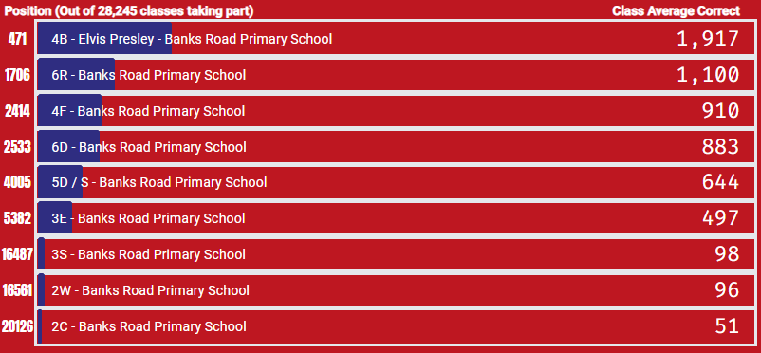
Class Results

Pupil Results
