**Expressive Arts and Design**

Your child will:

* Explore, use and refine a variety of artistic effects to express their ideas and feelings.
* Create collaboratively, sharing ideas, resources and skills.
* Sing in a group or on their own, increasingly matching the pitch.

**Physical Development**

**P.E day is Thursday.**

Your child will:

* Explore movement in various ways, moving in a more fluid style and develop grace and control.
* Develop their core strength, balance and co-ordination.
* Exercise their fine motor skills with resources such as play dough, clay, threading and building with small blocks.

**Literacy**

Your child will:

* Read and immerse themselves in the story book ‘The Something’.
* Plan and say a sentence accurately.
* Create a Story Map and retell the events of the story.
* Familiarise themselves with word and sentence structure.

**PSED**

*Express their feelings and consider the feelings of others.*​

Your child will:

* Be encouraged to think about how they have changed from being a baby and what may change for them in the future.
* Discuss and understand that change can bring about positive and negative feelings, and that sharing these can help..

**Understanding the World**  
  
Your child will:

* Understand the effect of changing seasons on the natural world around them.
* Talk about what they see, using a wide vocabulary.
* Observe how the weather changes across the four seasons.

**Homework**

Your child will:

* Bring a new reading for pleasure book home every Monday
* Receive phonics links to practice at home.
* Receive topic homework every other week.

**Communication and Language**

Your child will:

* Understand how to listen carefully and why listening is important.
* Learn and use new vocabulary.
* Ask questions to find out more information and to check they understand what is being said to them.

**Books we are reading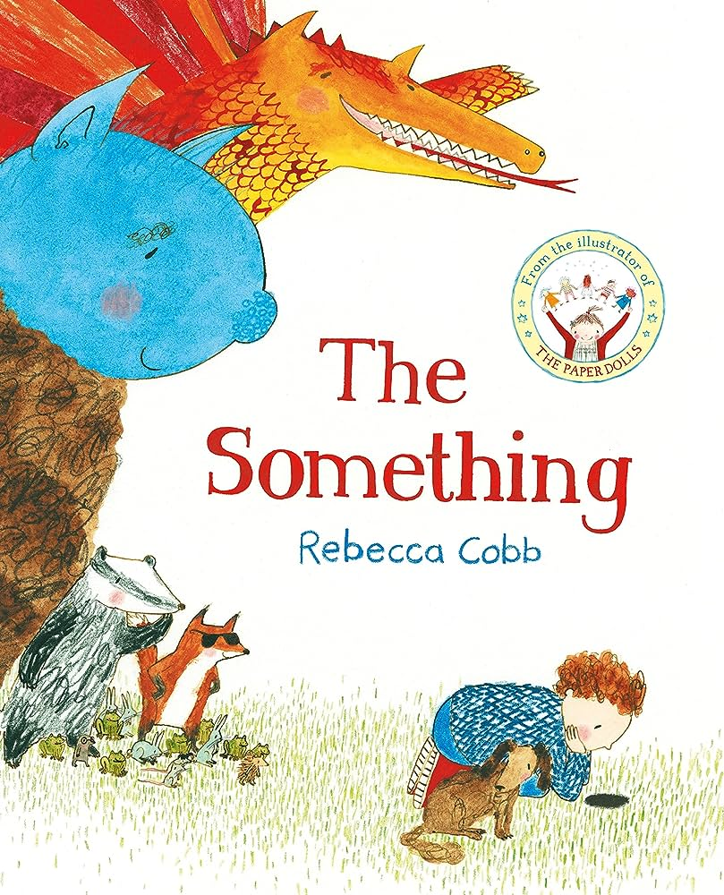The Something**

Please visit our website where you will find more information on our class page



**Maths**

This term’s White Rose topic is called ‘Getting to Know You’.

Your child will continue to:

* Practice counting up to 10 and beyond.
* Practice counting out a certain number of items from a large pile.
* Recognising numerals in the environment.