**Expressive Arts and Design**

Your child will:

* Listen attentively, move to and talk about music, expressing their feelings and responses.
* Explore and engage in music making and dance, performing solo or in groups.

**Physical Development**

**P.E day is Friday**

Your child will explore the following fundamental movements:

* Locomotor- Crawling, Walking, Leaping, Jumping (Height and Distance), Galloping, Twisting
* Body Control- Balancing, Turning, Bending, Landing, Stopping, Twisting, Swinging
* Object Control

**Literacy**

Your child will:

* Read and immerse themselves in the story book ‘Juniper Jupiter’.
* Plan and say a sentence accurately. Begin to write a simple sentence.
* Familiarise themselves with word and sentence structure. Use a sentence checker to remember to use capital letters, full stops and finger spaces.

**PSED**

*Dreams and Goals*

Your child will:

* Understand that if they persevere they can tackle challenges.
* Be able to set a personal goal and work towards it.
* Use kind words to support one another.

**Understanding the World**  
  
Your child will:

 • Name and describe people who are familiar to them.   
• Talk about members of their immediate family and community.

 •Demonstrate and talk about how they look after themselves

 • Talking about other people that look after them.

**Homework**

Your child will:

* Bring a new reading for pleasure book home every Monday
* Receive phonics links to practice at home.
* Receive Understanding the World homework every other week.

**Communication and Language**

Your child will:

* Ask questions to find out more and to check they understand what has been said to them.
* Develop their listening and attention skills during teacher led learning.
* Use new vocabulary throughout the day.

**Books we are reading**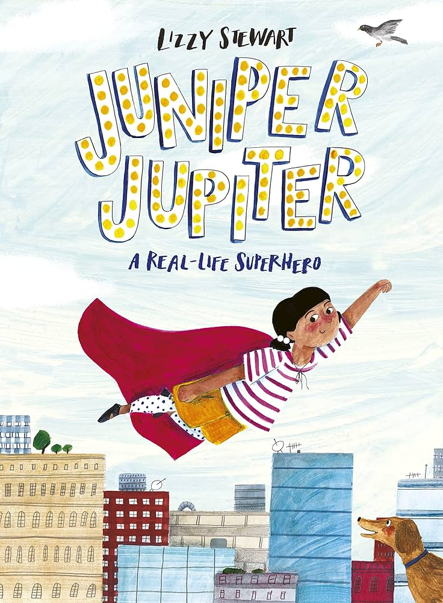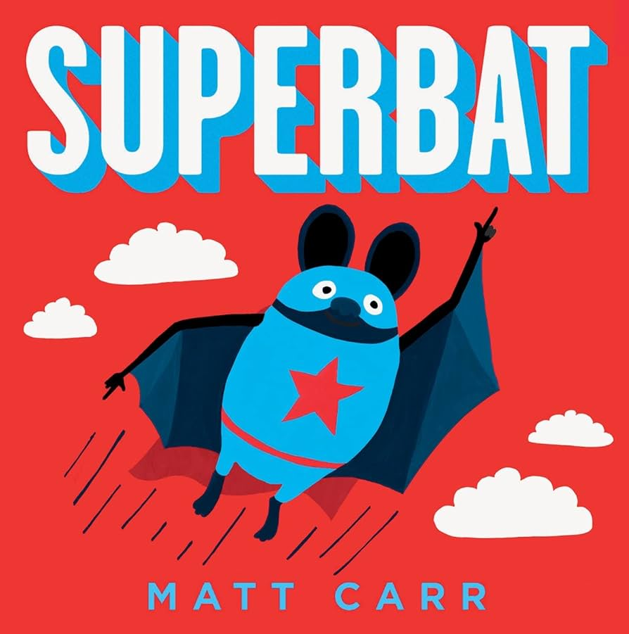

**Juniper Jupiter Superbat**

Please visit our website where you will find more information on our class page



**Maths**

This term’s White Rose topic is called ‘Alive in 5’.

Your child will:

* Confidently recognise numerals 0 to 10
* Link numerals with amount up to 5 and maybe beyond
* Use number names and symbols when comparing numbers.
* Add 1 and subtract 1.